Ideation Phase Brainstorm & Idea Generation

|  |  |
| --- | --- |
| Date | 26/10/22 |
| Team ID | PNT2022TMID36873 |
| Project Name | AI-Powered Nutrition Analyzer For Fitness Enthusiasts |
| Maximum Marks | 4 Marks |

Step-1: Team Gathering, Collaboration and Select the Problem Statement

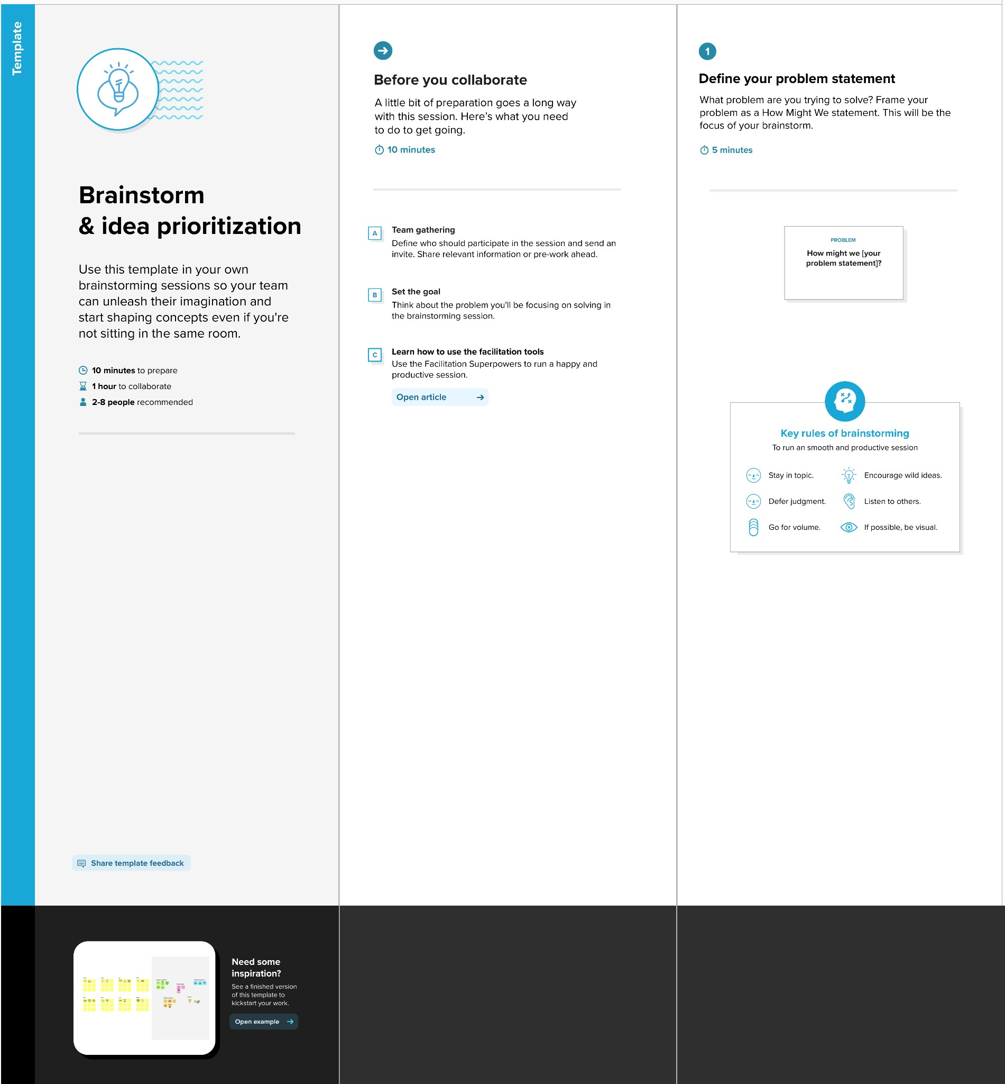

**Step-2: Brainstorm, Idea Listing and Grouping**

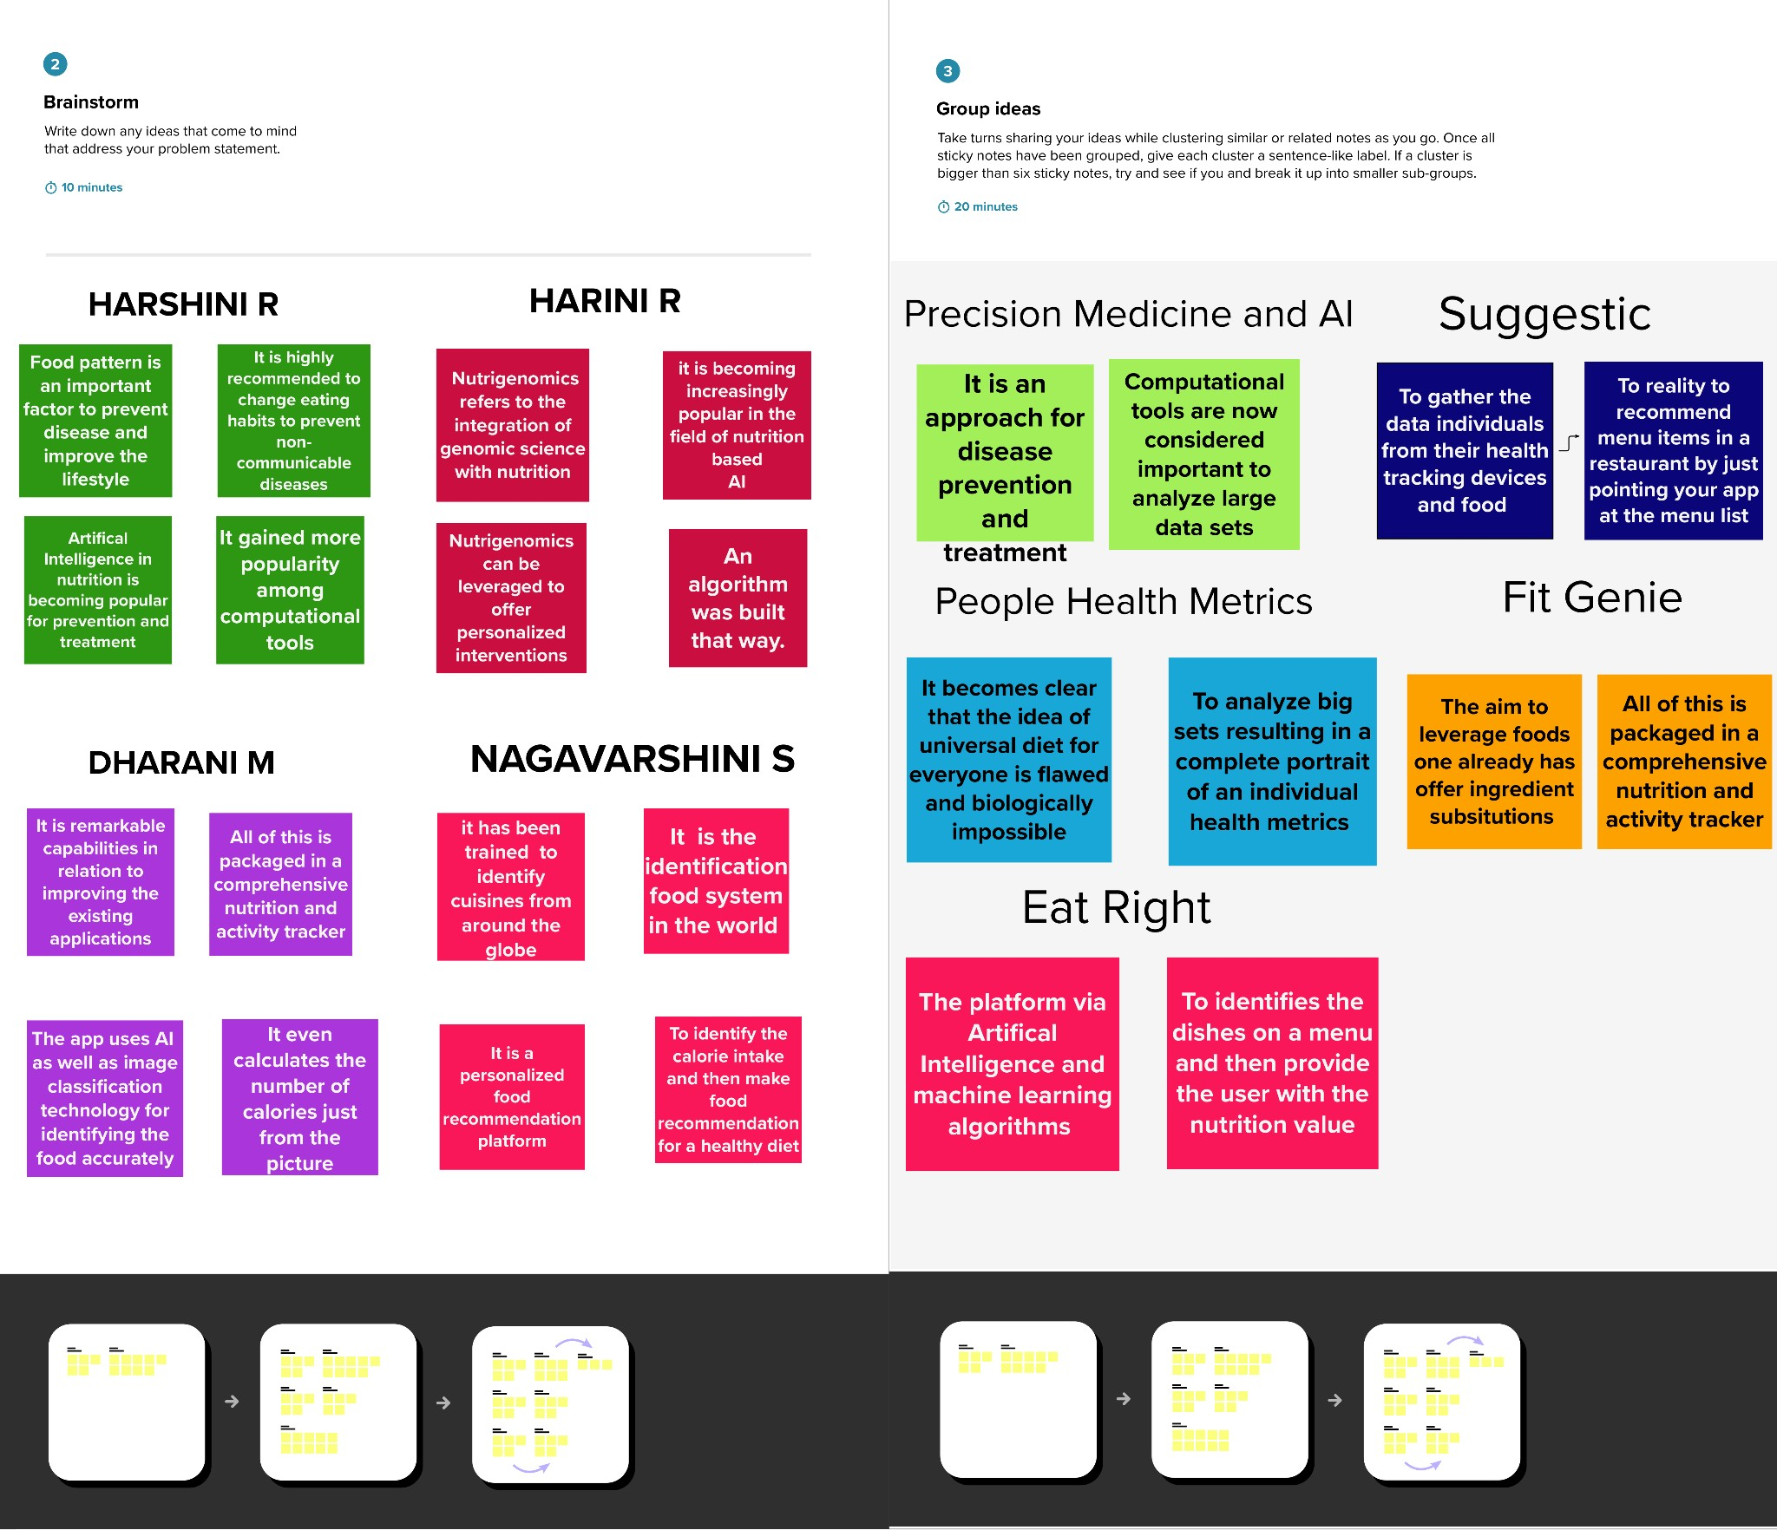

Step-3: Idea Prioritization

